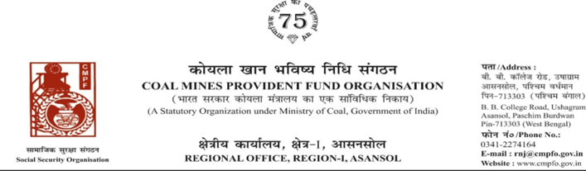
CPF/118/Misc/Ext-out/R-I/ASN/ Dated-25/07/2025

To
The Regional Commissioner
Coal Mines Provident Fund Ranchi R-II
Darbhanga House CCL HQ.Ranchi University
Morabadi
Ranchi (Jharkhand) 834001

Sub- Supply of Extract of "VV" statement

Ref:-CPF/Extract incoming/R-II/22 Dated-07/05/2025

Sir,

On the subject and reference cited above,enclosed please find herewith the extract in r/o-
Sri Achintya Lal Yadav CMPF A/C No- KTS/18/167 as required. Ledger Card is not available in this region.

Encl- As above

Yours faithfully

Assistant Commissioner

